Student Name: Chetan Prajapat
Project Title: SQL Mini Project – SmartMart Retail

Introduction
In this project, I worked as a data analyst for SmartMart Retail company.
The company sells products like Electronics, Clothing, and Home Appliances.
The main goal of this project is to analyze:
Best selling products
Sales by cities
Customer behavior
Category performance

Level 1 – Basic SELECT
SELECT * FROM customers;
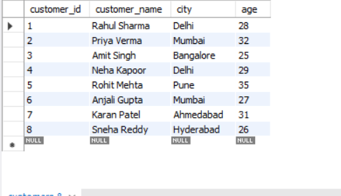

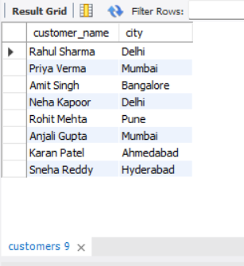
SELECT customer_name, city FROM customers;

SELECT * FROM products WHERE category='Electronics';
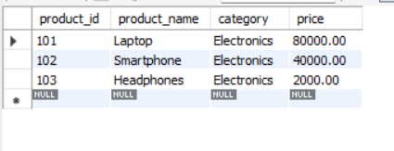
SELECT * FROM products WHERE price > 10000;
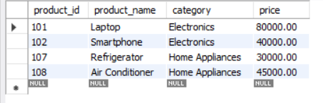

SELECT DISTINCT category FROM products;
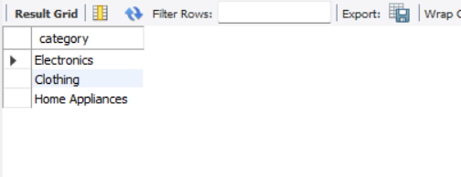

Level 2 – WHERE Conditions
SELECT * FROM customers WHERE city='Delhi';
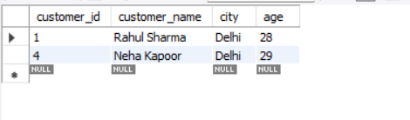
SELECT * FROM customers WHERE age > 30;
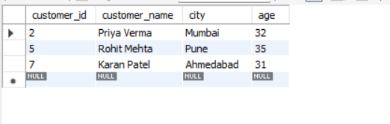
SELECT * FROM products WHERE price BETWEEN 2000 AND 50000;
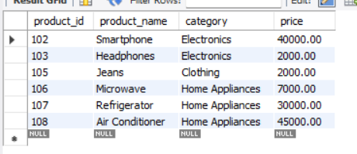
SELECT * FROM sales WHERE order_date > '2024-01-12';
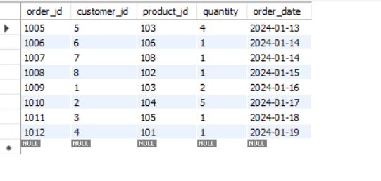

SELECT * FROM sales WHERE quantity > 2;
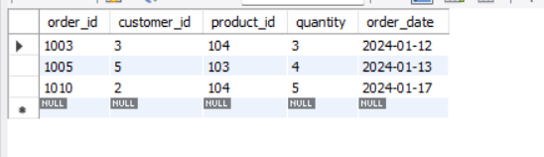

Level 3 – Sorting & Limiting
SELECT * FROM products ORDER BY price DESC;
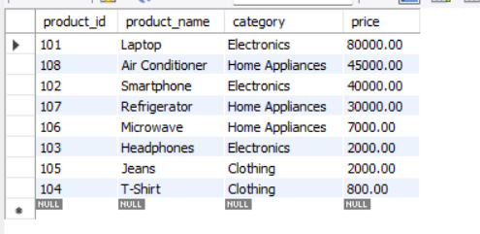
SELECT * FROM products ORDER BY price DESC LIMIT 3;
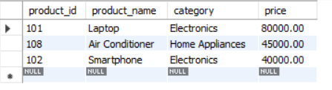

SELECT * FROM customers ORDER BY age ASC;
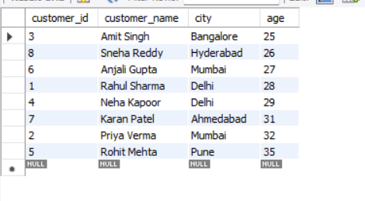
SELECT * FROM sales ORDER BY order_date DESC LIMIT 5;
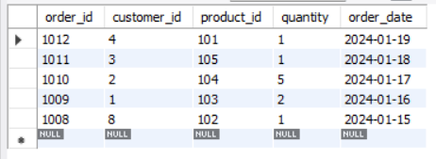

Level 4 – NULL Handling
UPDATE customers
SET city = NULL
WHERE customer_id = 8;
SELECT * FROM customers WHERE city IS NULL;
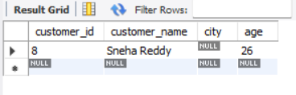

SELECT * FROM customers WHERE city IS NOT NULL;
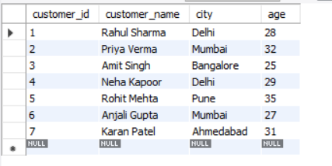

Level 5 – Aggregations
SELECT COUNT(*) FROM customers;


SELECT AVG(price) FROM products;
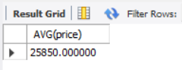

SELECT MAX(price) FROM products;
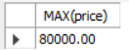

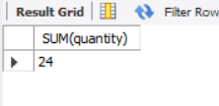
SELECT SUM(quantity) FROM sales;

Level 6 – GROUP BY
SELECT category, COUNT(*) FROM products GROUP BY category;
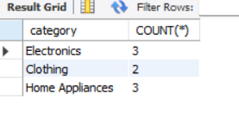
SELECT product_id, SUM(quantity) FROM sales GROUP BY product_id;
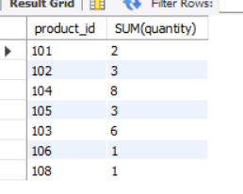
SELECT category, AVG(price) FROM products GROUP BY category;
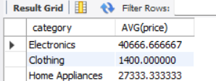

Level 7 – HAVING
SELECT category, AVG(price)
FROM products
GROUP BY category
HAVING AVG(price) > 10000;
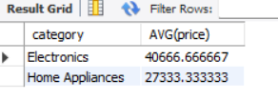
SELECT product_id, SUM(quantity)
FROM sales
GROUP BY product_id
HAVING SUM(quantity) > 3;
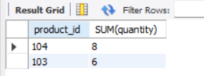
SELECT category, COUNT(*)
FROM products
GROUP BY category
HAVING COUNT(*) > 2;
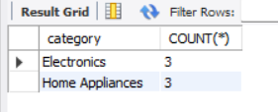

Business Questions
Most selling category
SELECT p.category, SUM(s.quantity) AS total_sales
FROM sales s
JOIN products p ON s.product_id = p.product_id
GROUP BY p.category
ORDER BY total_sales DESC
LIMIT 1;
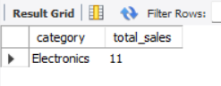
Most sold product
SELECT product_id, SUM(quantity) AS total_sold
FROM sales
GROUP BY product_id
ORDER BY total_sold DESC;
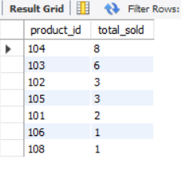

City with most customers
SELECT city, COUNT(*)
FROM customers
GROUP BY city
ORDER BY COUNT(*) DESC;
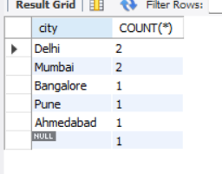

Highest price product
SELECT * FROM products
ORDER BY price DESC
LIMIT 1;
